Lab 1: Requirements Engineering & UML Use-Case Modelling

Objective:
From a short, instructor-provided scenario, elicit key functions and constraints; write clear, verifiable functional (FR) and nonfunctional (NFR) requirements; then translate them into a UML use-case diagram and one use-case flow.

Duration:
90 minutes

Software Requirements:
Draw.io, LucidChart, StarUML or any other online UML tool.

Learning Outcomes for Lab 1
By the end of this lab, students will be able to:
- Elicit and document requirements:
  - Write clear, testable functional requirements (FRs) and nonfunctional requirements (NFRs) from a given scenario.
  - Define measurable acceptance criteria and justify priorities.
- Model system behaviour:
  - Identify actors (e.g., Customer, Admin) and use cases for a software system.
  - Construct a UML use-case diagram with correct syntax (associations, «include»/«extend» relationships).
- Specify use-case flows:
  - Draft a main success scenario and alternate flows for a key use case (e.g., payment processing).
- Apply industry standards
  - Format requirements in a structured table (e.g., Req ID, Type, Description) akin to a Software Requirements Specification (SRS).
Note: Students may be randomly called for a presentation after completing the lab. Please be prepared to discuss your code, bugs you found, and how you fixed them.

Introduction:

Use case Modelling
Describes the interaction of users and the system
- Describes what functionality a system provides to its users.
- Use case models have two important elements - actors and use cases.
Actor/s: One or set of objects who directly interacts with the system. Every actor has a defined purpose while interacting with the system. An actor can be a person, device or another system.
Use case: A piece of functionality that a system offers to its users. Set of all use cases defines the entire functionality of the system. Also define the error conditions that may occur while interacting with the system

How to create Use case diagrams?
- List main system functions (use cases) in a column
- Draw ovals around the function labels
- Draw system boundary
- Draw actors and connect them with use cases
- Specify include and extend relationships between use cases
"Include" is used when a use case always calls another use case as part of its behavior (e.g., "Place Order" always includes "Process Payment").
"Extend" is used when a use case optionally adds behaviour to another (e.g., "Make Payment" can be extended by "Apply Discount", if applicable).
Use include for reuse, and extend for optional or conditional behaviour.

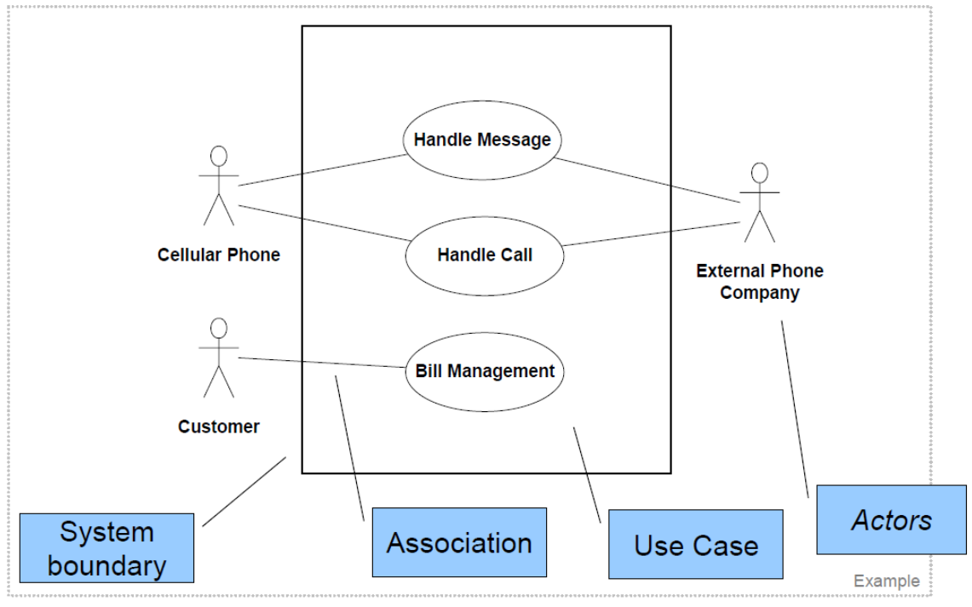
Example Use Case Diagram for a simple Telecom System:

Example Use Case Flow for a Simple Telecom System:

Use Case: Recharge Mobile Balance

Main Success Scenario:
- Customer selects the "Recharge Balance" option from the Telecom self-service kiosk or mobile app.System displays a form to enter mobile number and amount.
- Customer inputs a valid mobile number and recharge amount.
- System validates the inputs.
- System requests payment method selection (credit card/debit card/mobile wallet).
- Customer selects a payment method.
- System connects to the Payment Gateway.
- Payment is authorized.
- System updates the customer balance in the backend system.
- A confirmation message is shown and a receipt is printed or emailed.
- Use case ends successfully.

Alternate Flow

8a. Payment Declined
- 8a1. System displays a payment failed message.
- 8a2. Customer is prompted to try another payment method.
- 8a3. If payment fails again (after 2 attempts), the recharge process is cancelled and the customer is notified.

Scenario
Self-Service Coffee Kiosk
You are designing the software for a self-service coffee kiosk in a busy café. The kiosk must allow customers to:
- Select a coffee (Espresso, Americano, Latte, Cappuccino).
- Choose size (Small, Medium, Large).
- Customize add-ons (Extra shot, Soy/Almond milk, Syrups).
- Pay via credit/debit card or mobile wallet.
- Print a receipt with order details and loyalty points added.
The kiosk screen should be responsive and straightforward. Customers must complete a single order in under 60 seconds. Password-protected admin mode allows café staff to refill ingredients, update prices, and view sales reports.

Deliverables
- Requirements Table (Word/Excel):
  - Exactly five FRs, out of which two are given (FR-001) and two NFRs out of which one is already given. (NFR-001), each with:
    - Req ID
    - Type (Functional/Nonfunctional)
    - Description (“The system shall…”)
    - Priority (High/Medium/Low)
    - Acceptance Criteria (measurable pass/fail)
    - Rationale (short justification)

- UML Use-Case Diagram (PDF)
Showing all actors, use cases, and at least one «include» or «extend» relation.

- Use-Case Flow Document (Word, one page):
  - For one key use case (e.g., “Place Order”), provide:
    - Main Success Scenario (step-by-step).
    - Alternate Flow, at least one (if payment is declined, for example).

Lab 1 Steps (90 min)
- Introduction & Scenario Review (5 min)

- Elicit & Draft Requirements (35 min)
  - Brainstorm (10 min):
    - List all the possible functions (e.g., “Select coffee type”) and constraints (e.g., “Order < 60 s”).
  - Populate Requirements Table (25 min):
    - Use the template below.
    - Fill in exactly five FRs and two NFRs.
    - After drafting, each table row must include measurable acceptance criteria.
    - Example FRs/NFRs (for guidance; students must write their own phrasing):
Req ID | Type | Description | Priority | Acceptance Criteria | Rationale (short)
FR-001 | Functional | The system shall allow a customer to select a coffee type (Espresso, etc.) | High | When a customer taps “Espresso,” the screen highlights Espresso and displays “Size” | Core ordering functionality
FR-002 | Functional | The system shall allow the customer to select a drink size. | High | When a size is selected, it is shown as chosen and the next step is prompted. | Required for price calculation and preparation
FR-003 | Functional
FR-004 | Functional
FR-005 | Functional
NFR-001 | Nonfunc. | The system shall complete any order (selection to payment) in under 60 s. | High | A timing log shows < 60 s from first tap to transaction approval | Ensures quick service during peak hours
NFR-002 | Nonfunc.

- Extract Actors & Use Cases (10 min)
  - From the approved requirements, list:
    - Actors (at least three)
    - Use Cases (at least five)

- Draw an UML Use-Case Diagram (20 min)
  - Open a UML tool (e.g., draw.io or Lucidchart).
  - Actors on left:
    - Draw stick figures: Actors
  - Use Cases (ovals): label them UC-01…UC-05 with titles.
  - Associations
    - (At least one «extend»/<<include>> relationship is required: see step 6 below.)
- Write One Use-Case Flow (20 min)
  - Pick a UC: In a separate page, draft:
    - Main Success Scenario
    - Alternate Flow
- Finalize & Export (5 min)
  - Use-Case Diagram: Export as PDF.
  - Use-Case Flow: Export as PDF.
  - Submit both files plus the revised Requirements Table.

